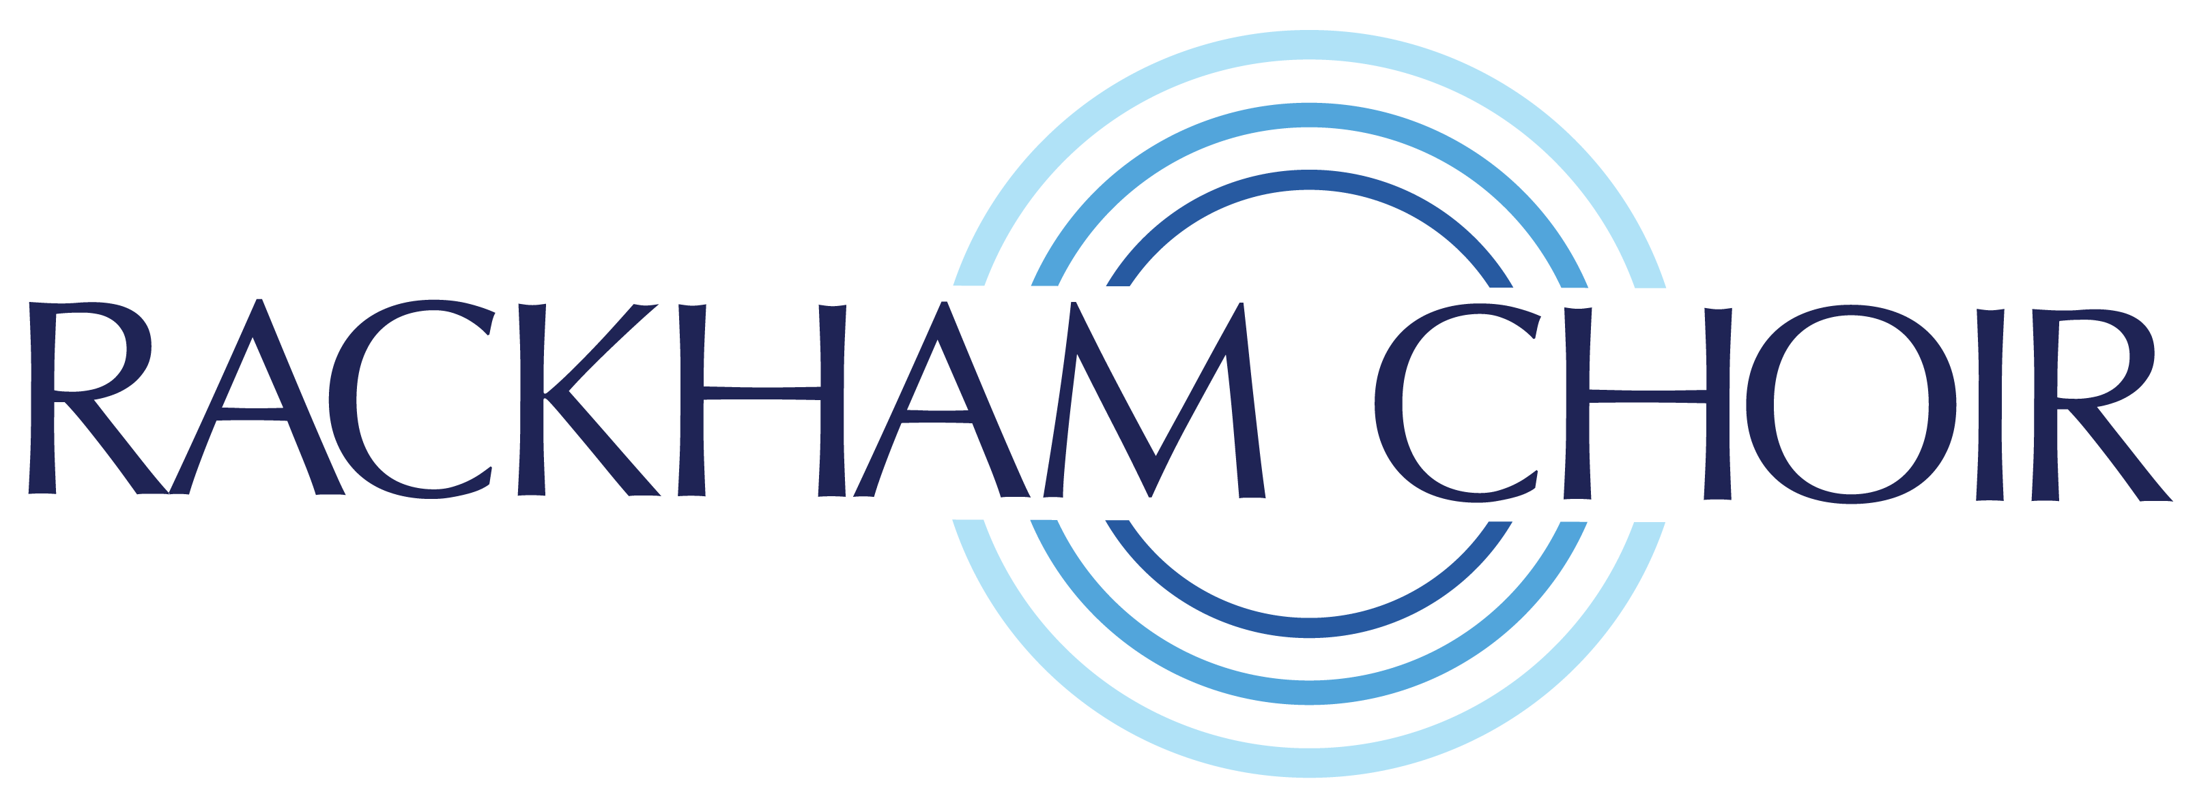
Rackham Choir
Audition Form

Auditions are held on Tuesday Evenings
at First Presbyterian Church, Royal Oak, 529 Hendrie Blvd,
Royal Oak, MI 48067

Please provide the following details and return to Rackham Choir via email to: administration@rackhamchoir.org

Name:

Phone: Email:

Address: City, State:

Voice Part:

Information: Please provide a brief description of your Vocal Training, Education and Experience.

Referral:

